IITC photo selection

Total for home page image 1-? Depends on if additional quote will be provided.

Total of 6 section photos needed (about, technical, contracts, careers, contact, employee)

**Binary code panorama** Stock photo - File #: 13264804[Photos and illustrations by contributors whose royalty-free stock is only available from iStockphoto and the Getty Images family of companies and their distribution partners](http://www.istockphoto.com/icons.php)  
To be used on: Home Page



**Patti’s photo #1 –** birds in sunlight (NO CHARGE)  
To be used on:

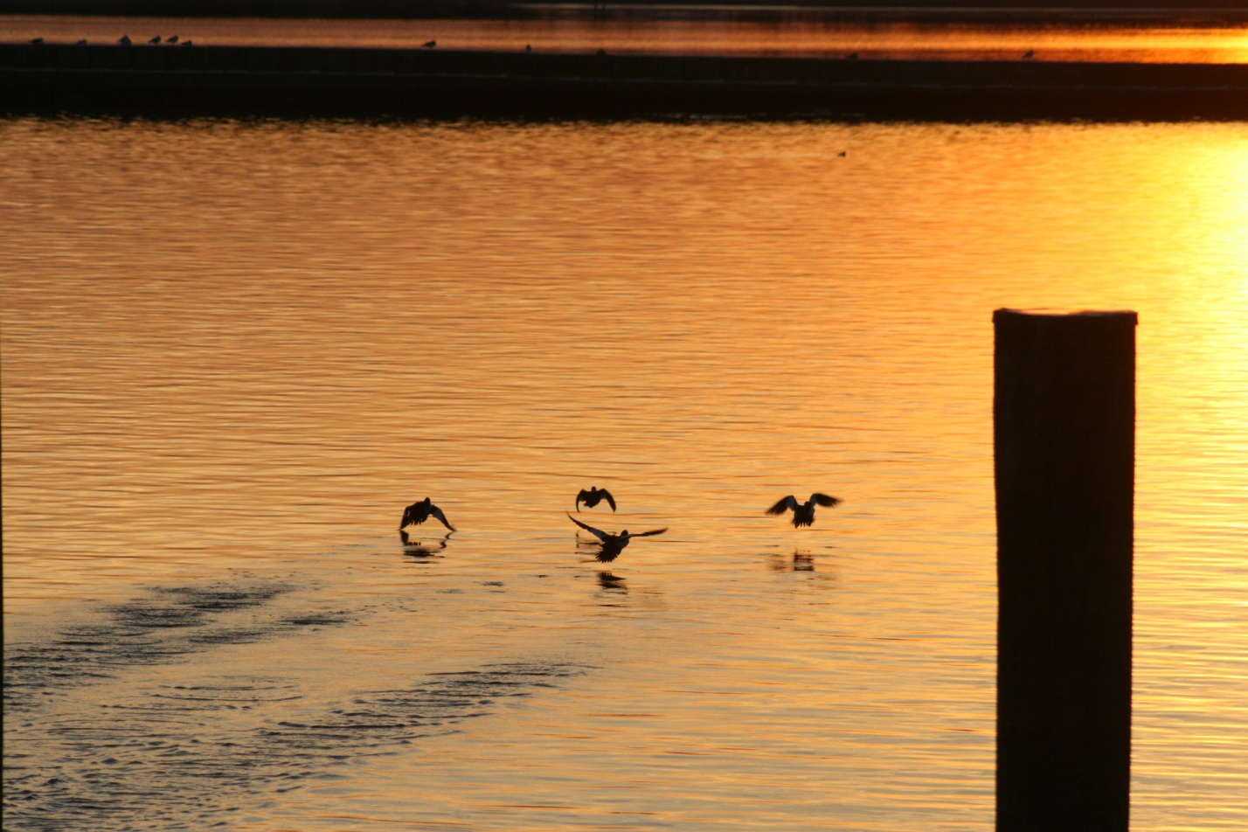

**Patti’s photo #2** – crabs (NO CHARGE)  
To be used on: Employee page

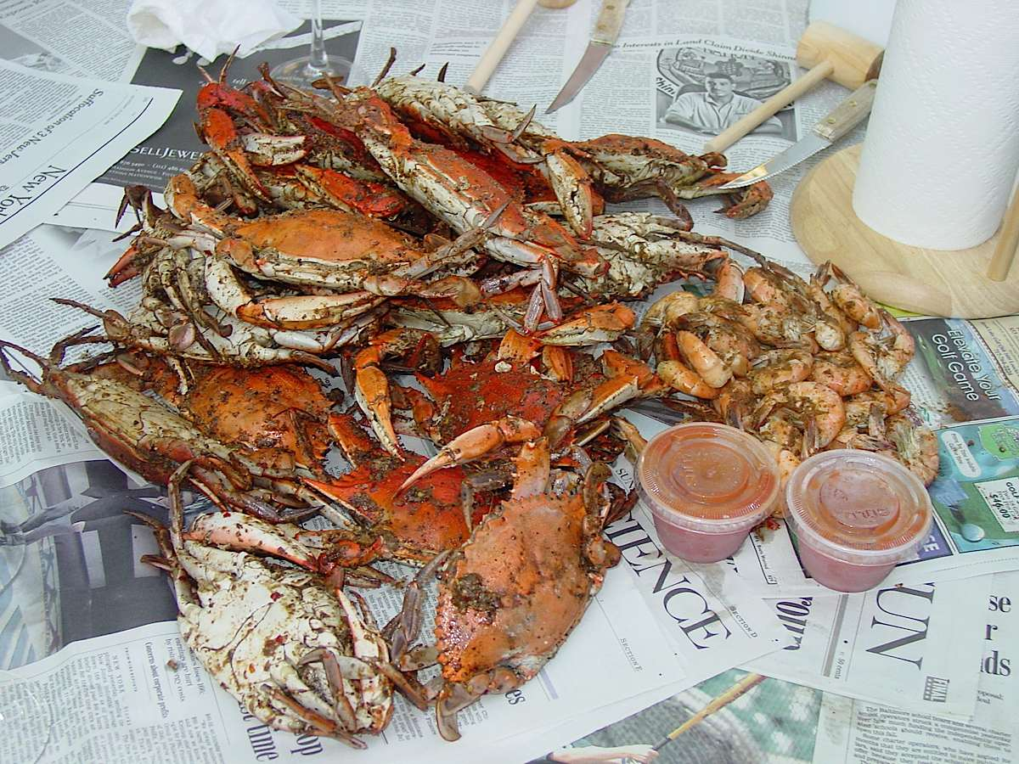

**Sunset - Geese Landing** – istockphoto File #: 3992144[Photos and illustrations by contributors whose royalty-free stock is only available from iStockphoto and the Getty Images family of companies and their distribution partners](http://www.istockphoto.com/icons.php) [Photos and illustrations by contributors whose royalty-free stock is only available from iStockphoto and the Getty Images family of companies and their distribution partners](http://www.istockphoto.com/icons.php)(10 credits x 1.54 a credit = 15.40)  
To be used on:



**Bay bridge summer** istockphoto File #: 6869444 [Photos and illustrations by contributors whose royalty-free stock is only available from iStockphoto and the Getty Images family of companies and their distribution partners](http://www.istockphoto.com/icons.php)(10 credits x 1.54 a credit = 15.40)  
To be used on:

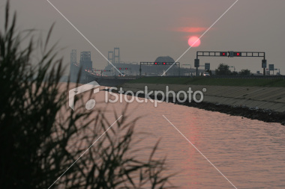

**Business woman** istockphoto File #: 8800639[Photos and illustrations by contributors whose royalty-free stock is only available from iStockphoto and the Getty Images family of companies and their distribution partners](http://www.istockphoto.com/icons.php) [Photos and illustrations by contributors whose royalty-free stock is only available from iStockphoto and the Getty Images family of companies and their distribution partners](http://www.istockphoto.com/icons.php)(10 credits x 1.54 a credit = 15.40)

# To be used on:



# Network hub – istockphoto # 6993920 - [Photos and illustrations by contributors whose royalty-free stock is only available from iStockphoto and the Getty Images family of companies and their distribution partners](http://www.istockphoto.com/icons.php)(10 credits x 1.54 a credit = 15.40) To be used on:



**Fixing network server** - Stock photo - File #: 10404107[Photos and illustrations by contributors whose royalty-free stock is only available from iStockphoto and the Getty Images family of companies and their distribution partners](http://www.istockphoto.com/icons.php)**[Photos and illustrations by contributors whose royalty-free stock is only available from iStockphoto and the Getty Images family of companies and their distribution partners](http://www.istockphoto.com/icons.php)(75 credits x 1.54 a credit = 115.50)**  
To be used:   
  


**Note:  
Sunset 1 and Sunset 2** not wide enough to use in main photo area at top of pages. But could be used within content of site if you wanted.  
